Assignment 1 – User Needs Analysis (70 points)

| **Due date:** | See CANVAS for submission deadline and instructions. |
| --- | --- |
| **Objective:** | The goal of this assignment is to define the project scope, understand the needs of potential users, and gain deeper knowledge of the design problem through discussions with technical experts. |

1. Project Scope (/5 points)
2. **Problem Statement**. Describe the goal of this project in your own words (2-3 sentences, not copied from the project description) (/2 points)

Tracked and wheeled robots are messy and imprecise which makes it difficult to navigate through sensitive crops. Quadruped robots are more capable but tend to either be vastly overpriced or difficult to modify for specific tasks. This project is designed to remedy that by building a quadruped that is cost effective and easy to specialize.

1. **Scope.** Complete the following table detailing the required project scope, optional additional scope, and elements outside the project scope. Rank items in the “optional additional scope” column in order of priority (1 = highest priority additional scope item) (/2 points).

| Must be part of scope | Optional next steps (rank) | Not included in Scope |
| --- | --- | --- |
| 1. Runs on ROS 2 2. Use ROS 2 Humble (convert original code from Foxy) 3. Autonomous; no tether (First prototype on tether) 4. On-board Power System that can run for 1-2 hours 5. Can navigate to four points in a field. 6. Modify design to enclose electronics. 7. Easily storable, carryable (handles, box) 8. Utah red colors | 1. Fully assembled by end of first semester (Fiberglass infused ABS) 2. Rebuild chassis with stronger materials during second semester (machined aluminum) | * Additional actuators * Additional sensors * Efficient walking * Large Deviations from Open Dynamic Robot Initiative * Manipulators * Radio beacon following * 12 degree of freedom |

1. List all possible users of your design. Be sure to include both “mainstream” and “extreme” users, as discussed in class (/1 points).

Mainstream: Agricultural workers who want a cost effective tool to check hard to reach crop sites, agricultural researchers looking for a small cost effective test bed, farmers, land surveyors, potential other industrial users looking for a cheap quadruped alternative.

Extreme: Tinkerers or researchers who want to modify and experiment with robot behavior

1. User Interviews (/20 points)

Conduct interviews of **two** potential users of your design. Due to the importance of gathering outside input in the early stages of design, project team members and team faculty advisors do not qualify as users for this assignment. Complete the following table for each user interview. Provide detailed notes from your interview in the Appendix to this assignment, *including a list of questions/materials prepared by design team in advanced of interview* (part E).

1. User #1 (/10 points)

| Interviewee: | John Sanchez |
| --- | --- |
| Interviewer(s): | Kevin Nelson, Samuel Spencer, Jordan Raver, Yang Yang, Ben Seisser |
| Interview location/time/duration (/1 point for rows 1-3): | Zoom, 12:00 pm September 13th, 35 minutes |
| Explain why the interviewee is a good candidate for understanding user needs (3-5 sentences) (/1 point): | John Sanchez is an agricultural researcher at Utah State University. He has a mechanical engineering PhD and has a history of working on a farm. He will provide the perspective of an advanced user who has a good understanding of the functionality of the robot. |
| What technique(s) that we learned in class did you use in conducting this interview? See Chapter 3, Table 1 for documentation to include with your technique(s) (/1 point) | Mainstream vs Extreme |
| Summarize your key findings from the interview (3-5 bullet points) (/3 points): | * State observability (1D) is an issue when dealing with radio signals localization. * Simple radio, bluetooth, and ultra wideband sensors can accomplish signal triangulation via particle filtering. * Quadrupeds can be used to check water levels more effectively than a flying drone. * Crop height monitoring can be accomplished with less sophisticated sensing. * Cold and hot weather will be a challenge for robots as well as muddy soil. * Corn and other crops will be challenging to avoid/not damage. * Waterproofing could prove important. * Price point expectation of a top tier product would be 10k-11k, low end would be 2k-3k. |

Additional points:

* List of questions/materials prepared by design team in advanced of interview (include in Appendix) (/2 points)
* Detailed interview notes provided in Appendix (/2 points)

1. User #2 (/10 points)

| Interviewee: | Cody Zesiger |
| --- | --- |
| Interviewer(s): | Yang Yang, Samuel Spencer, Austin Neff |
| Interview location/time/duration (/1 point for rows 1-3): | Zoom, 4:30 pm September 11, 30 minutes |
| Explain why the interviewee is a good candidate for understanding user needs (3-5 sentences) (/1 point): | Cody is a biology professor of a USU extension. He works as an intermediary between the agricultural industry and the associated research department. His background is in horticulture. His work would often be about understanding the needs of the agricultural industry, so he can give us some insight into those needs. |
| What technique(s) that we learned in class did you use in conducting this interview? See Chapter 3, Table 1 for documentation to include with your technique(s) (/1 point) | We used the extreme vs mainstream technique. |
| Summarize your key findings from the interview (3-5 bullet points) (/3 points): | * It would be beneficial for a robot to do crop condition monitoring, weed destruction, harvesting, and interface with systems in the field (valves). These are things that tractors cannot do. * It could replace agricultural laborers, which often includes housing and even food sometimes. * If it could navigate down crop rows without crashing and transition to the next would be ideal. * Most extreme situations include flood waters and corn fields (many objects). * Future needs would be manipulators such as an auger for soil samples and a coil for detecting buried markers. * Wet ground, or snow will be challenges. January, February, and late in March will be windows for testing. |

Additional points:

* List of questions/materials prepared by design team in advanced of interview (include in Appendix) (/2 points)
* Detailed interview notes provided in Appendix (/2 points)

1. Technical Expert Interviews (/10 points)

Conduct an interview of **one** technical expert that can provide insight into your design challenge. Technical experts may have knowledge related to engineering challenges specific to your design, or particular applications of your design. Your faculty advisor may NOT be your technical expert, but can help you identify a relevant technical expert. You are encouraged to find a technical expert that is NOT a faculty member in the mechanical engineering department. Complete the following table for your interview. Provide detailed notes from your interview in the Appendix to this assignment, *including a list of questions/materials prepared by design team in advanced of interview* (part E).

1. Technical Expert (/10 points)

| Interviewee: | Jacob Anderson |
| --- | --- |
| Interviewer(s): | In-person Kennicott building (Study Room A), 11:00 AM. |
| Interview location/time/duration (/1 point for rows 1-3): | MEK2445, 11am-12pm, total duration of 30 minutes |
| Explain why the interviewee is considered a technical expert for your project (3-5 sentences) (/1 point): | Jacob is a graduate student in the Mechanical Engineering department at the University of Utah. He has experience with quadruped robots in a laboratory environment. He is experienced in ROS 1, which is similar to what we will be using to implement our design solution (ROS 2). |
| What technique(s) that we learned in class did you use in conducting this interview? See Chapter 3, Table 1 for documentation to include with your technique(s) (/1 point) | We used the draw-it and asked why. |
| Summarize your key findings from the interview (3-5 bullet points) (/3 points): | * Functionality should be feasible in ROS Humble from Foxy. * Twelve degrees of freedom will be much higher complexity. * Mechanical limitations of 8 vs 12 degrees of freedom can limit stability. * Motion planning should be naive/simple for beacon locating. * There shouldn’t be any limitations to onboard processing based on the microcontroller we are using. |

Additional points:

* List of questions/materials prepared by design team in advanced of interview (include in Appendix) (/2 points)
* Detailed interview notes provided in Appendix (/2 points)

1. User Needs Testing (/20 points)

The goal of user needs testing is to place yourself in the “shoes” of your prospective users, and see the design problem from their perspective. User needs testing activities are also known as “empathy-oriented prototypes”, because they help you to experience the design problem first-hand.

Examples of user needs testing include but are not limited to:

- Physical tests that help you understand design constraints (e.g. size, weight, etc.);

- Spending time with users and documenting their experiences (e.g. photo-journal);

- Extensive background research on the design environment (if you can’t directly go “into the field”);

- Simulating the user environment and challenges;

- Experimenting with existing design solutions or related devices and documenting their advantages/limitations;

One “large” user needs tests or several “small” tests are acceptable, as long as multiple insights into user needs can be gained (see question 3).

1. Describe the goal of your user needs testing in one paragraph (e.g. what are you trying to learn?) What user group(s) are you seeking to understand? (/4 points):

We are focusing our user needs testing on the agricultural research community. We want to gain a better understanding of the agricultural testing field environment. We need to know what kinds of obstacles the robot will face and how large the field is in which the robot will be operating. We want to learn what sort of facilities the user will tend to have access to for maintaining the robot. We want to know what kinds of elements (rain, UV exposure, and dust) which the robot will be exposed to.

1. Describe what you did for your user needs testing exercise in one paragraph (e.g. activities/tasks performed, prototyping conditions/set-up, etc.) (/4 points).

We started our user needs testing by printing out some STL files from the open source project on generic PLA. We researched the agricultural research field and collected photos. The team analyzed the photos of the field to determine what conditions are like (eg. terrain, size). Interviews with potential users provided insights into what kind of conditions may exist in the field. We also experimented by lifting various weights to determine what would be an appropriate weight for the robot, since it may need to be carried around.

1. Summarize the key findings from your user needs testing experience (6-10 bullet points) (/6 points):

* A robot would need to be cost effective enough to justify replacing the labor
* An agricultural robot should eventually be able to navigate muddy and uneven terrain
* A method should be developed to avoid obstacles, either by pathing or sensing
* A robots tasks should replace repetitive tasks or tasks done at unusual hours, like late at night
* Location sensing using radio can be limited and would benefit from multiple methods to increase accuracy
* Part printing with ABS can be tricky and both standard ABS and PLA can result in some rough surfaces where the supports connect. Advanced versions of these materials have better finishes
* Robots are extremely expensive, certain parts can and should be exchanged/replaced based on needs
* Fields are large; the robot would need to have good battery life to access the entire field

1. Include detailed notes/photos/videos from your testing experience in the Appendix of this assignment (or upload as supplementary files on Canvas) (/6 points)
2. Prioritized List of User Needs (/15 points)
3. Create a bulleted list of user needs. This list should come from your interview notes and notes from your user needs testing. (/12 points)

* Robust against weather and field conditions (1)
  + Temperature resistance
  + Water tight
  + Mud/snow navigation
* Relatively simple command system (4)
  + Ask it to do a thing, it figures out the specifics
* Priced under $10k for given functionality (6)
* Capable of avoiding crop damage (3)
* Modular Functionality – a mount for sensors or tools (7)
  + Outside of scope but something to leave room for on our chassis design for future projects
* Doesn’t get itself stuck in crops, holes, mud (2)
* Wireless data submission system (8)
* Sufficiently long battery life or ability to pause task and charge itself, user should not have to worry about charge (5)

1. Add rankings to the each need in the list created in part 1. Add the rankings to the list. Describe the ranking system you are using (i.e. what does 1, 2, 3, etc. mean?). (/3 points)

1 => Most valued need (absolutely necessary), 8 => Least valued need (Nice to have, unnecessary)

1. Appendix (points included under part D, User Needs Testing)

Include the following supplementary material in the Appendix to Assignment 1:

1. Notes from user interviews. Include questions/other materials prepared by design team for interview.
2. Notes from technical expert interviews.
3. Notes, photos, and/or videos documenting your user needs prototype.

**Technical Expert Interview Questions:**

* How does 12 DoF impact mobility and complexity versus 8 DoF?
* What are some challenges with battery power for extended times (possibly prompt weight management, runtime for full run or wander)?
* Are there any considerations that should be made with regard to onboard processing power?
* What are the biggest stability and navigation limitations for a quadruped?
* What are some differences between ROS and other coding systems (Arduino, MATLAB) to look out for?
* What are some possible difficulties/differences between ROS2 versions?
* What is JTAG emulation and does it require a specific (now obsolete) part or would any work?

**Technical Interview Notes:**

8 DoF is almost certainly better, complexity increase not worth benefits.

Battery efficiency dependent on inherited code

Processing power should not be an issue

Motion planning, simulate series of points and classical controls for simple navigation.

Stability depends on how good of a gait is in inherited code. Unlikely to need to modify.

ROS node system (picture)

ROS2 versions likely to be extremely similar, ROS1 v ROS2 removal of master and build system changes

JTAG unknown, probably a generic protocol

Lots of mention of the quality of gait in the base code and how that is likely the biggest factor for the robot’s ability to move and function successfully.

Drawing:

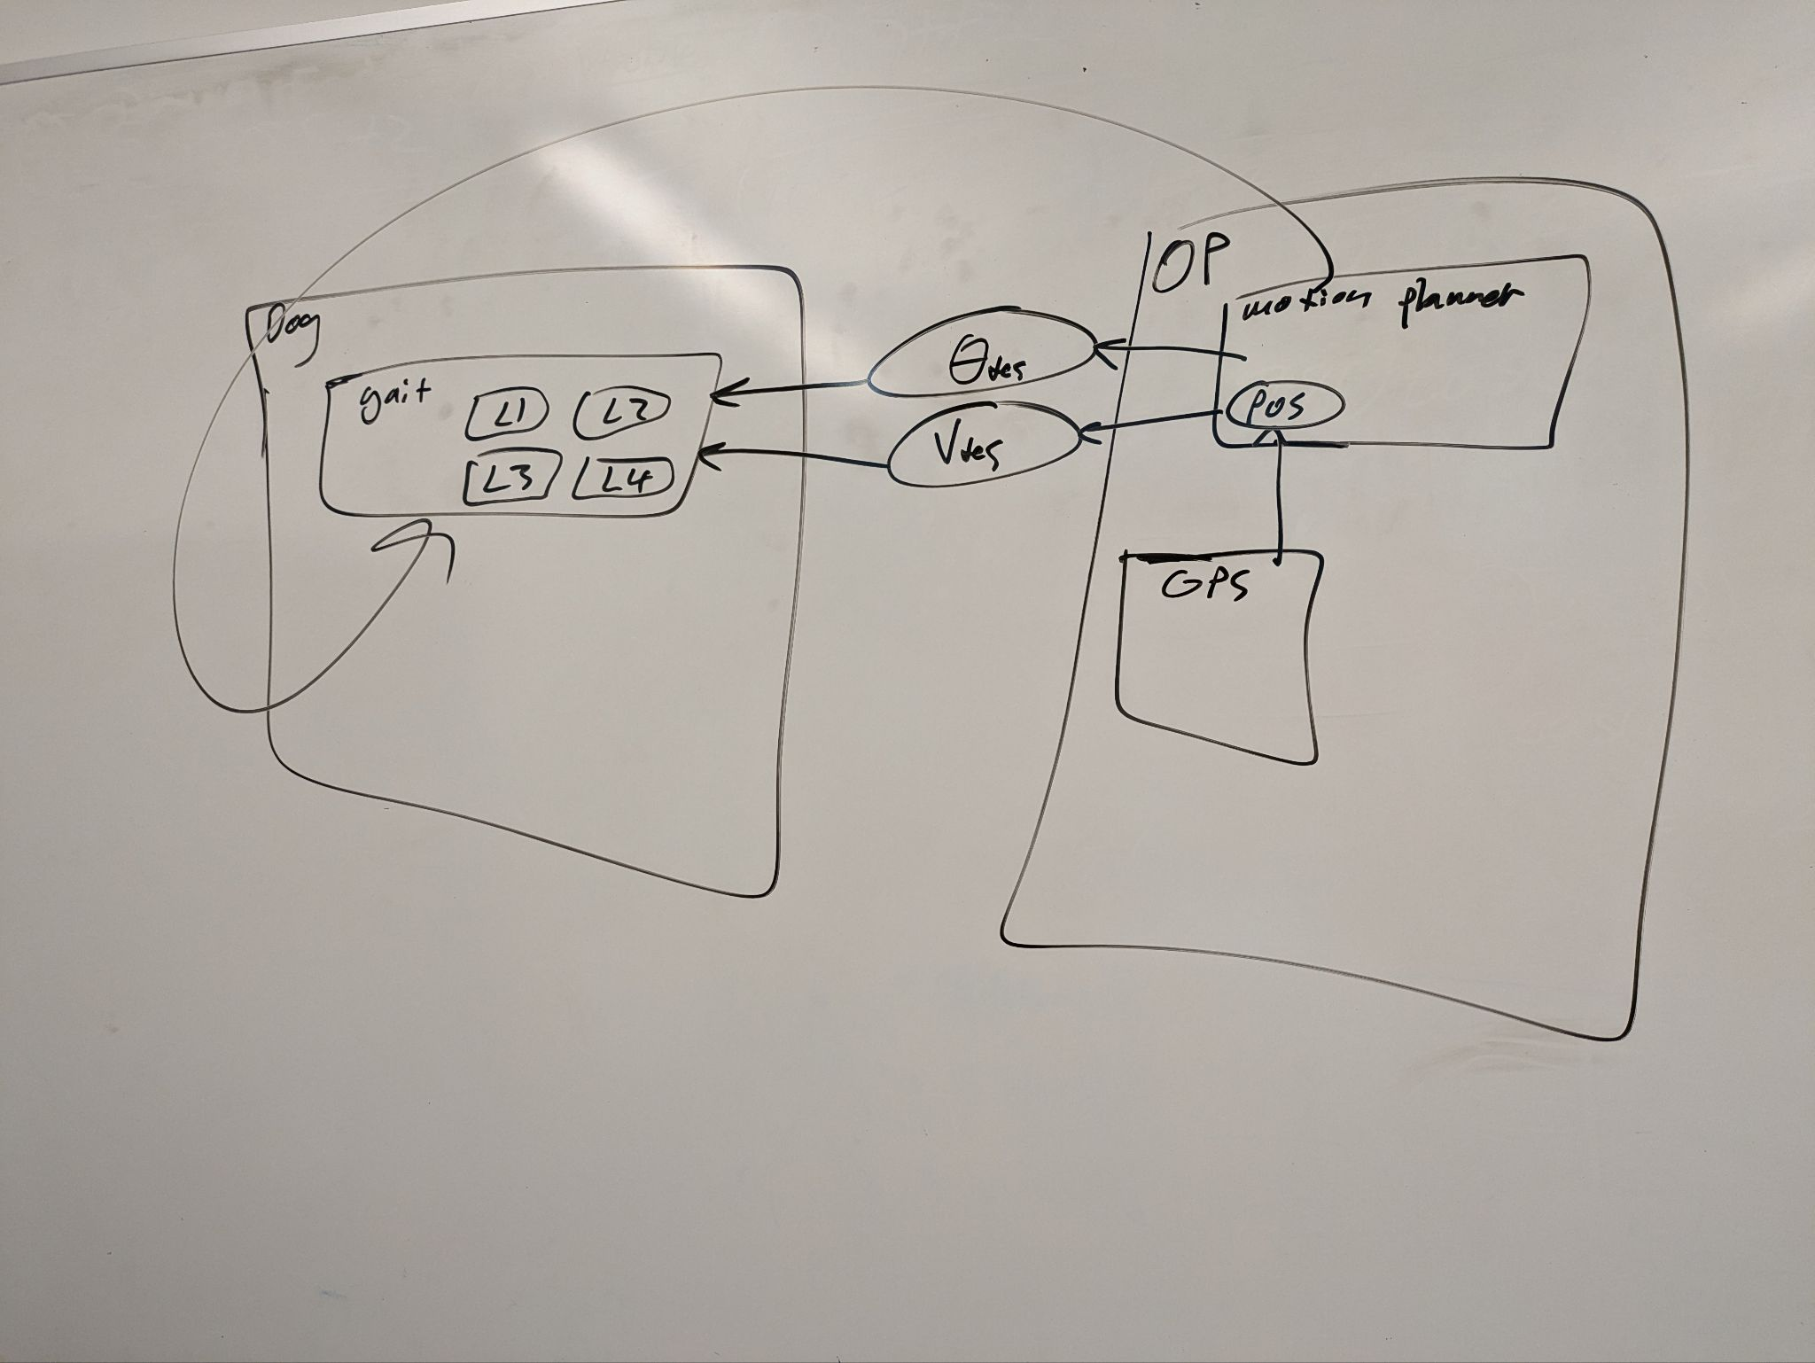

Diagram of how ROS behaves. OP is the orange pi board that would control the quadruped (dog), containing the topic position inside of the node motion planner. Motion planner outputs data based on position to the topics Θdestination and Vdestination. The node gait (which actually commands the leg motors L1 through L4 on the quadruped) is subscribed to those topics and reads them whenever they change. The arrow encircling it all was in description of how ROS does not behave–sending data directly between nodes, information must be transmitted through a topic.

**User Interview Questions:**

* What do you typically use a robot (quadruped or otherwise) for (if at all)?
* What could a cost effective quadruped replace/what uses would you have for a robot?
  + If not a lot, press with “what are things you wouldn’t expect from a cheap robot?” “What might a tracked robot be incapable of that a legged robot could do?”
* What parameters do you expect a robot to be able to accept?
* What are some pain points with existing designs (if there is experience with existing designs)?
* What are the most extreme situations a quadruped may end up in?
* What information might you want a robot to be able to collect?

**User Interview Notes:**

**Cody Zesiger User Interview**

What a robot would be used for:

- Crop Monitoring

- Turning things on/off

- Performing field tasks

- Auguring (for Soil Samples)

Primary Use: Possibly replacing laborers,

- >$600/acre costs need to be replaced for practicality

o Highly repetitive

o Strange hours

o Eliminates high production costs

- *Weeding

- *Harvesting by hand

- Irrigation Management

o Opening/close valves

o Wheel Lines

- Imaging, sample collection, monitoring

- Coactive crop monitoring

- Possible Scope: Robot that can note crops and walk down rows

*Highest cost items

Parameters:

- Going down fields, avoiding crops, don’t kill the robot

- Difficulty with fields

o Plowed Fields have varying ground heights

o Vines/stalks can stop the robot

o Raised beds

o Floodwaters, puddles, mud

o Snow, thawing soil (muddy)

- Possible scope: Images, sampling (+devices to attain sample)

Pain Points:

- Getting a lot of samples, moisture, weeds, other repetitive tasks

- Costs (Many robots are limited by who can afford them)

Timeline:

- Avoid snow

- Testing: Late March-May: 3-5 During Dry Down

- Jan-Feb: Small tests or use U of U lawn

**John Sanchez User Interview:**

Integrated agriculture robot onto a different vehicle with radio and GPS to measure underground coils (transmitter current) by aligning

- Signals varying with “coupling factor” Vout/Vin * Coefficient based on lateral separation and alignment, transfer media

o Mapping issues, state observability, Radio is 1D, particle filtering machine learning, radio, maybe ultra-wide band radio

- Other robot tasks; pesticides, *moisture monitoring

- Temperature issues can cause parts to fail (temperature rating), crops and navigating around

- Waterproofing, add desired positioning, at least 6” – 12” off the ground

- Particle Filtering navigation

- Muddiness is terrible

- DJI Agricultural Drones are a good price estimate

**User Needs Testing Photos:**

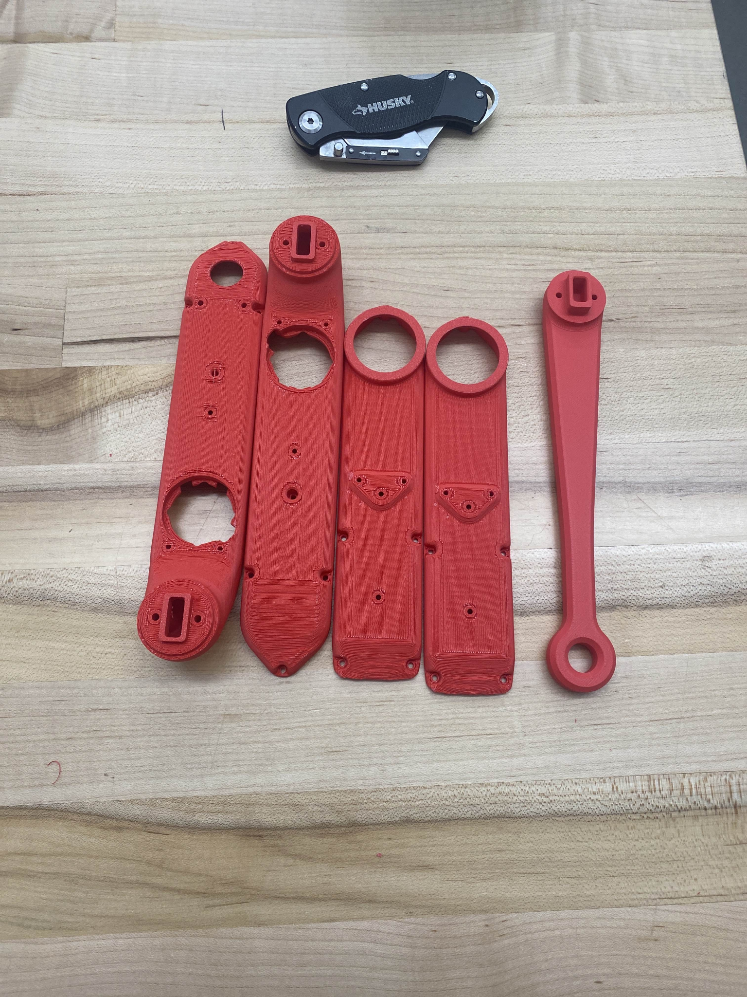  
Printing out first round of open-source parts using red PLA by Ben Siesser

* Finish of this set of parts is not very good. A production-ready version absolutely needs higher quality material
* Durability is sufficient for lab testing but not ideal for field testing
* Parts are small enough to print all components for one leg on one bed

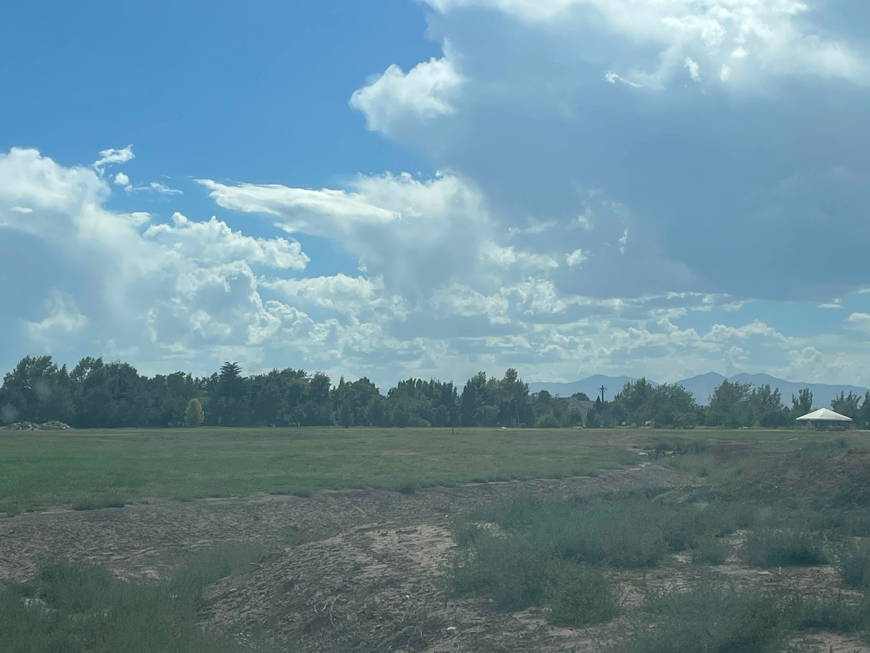A test field, lots of rough terrain, rocks, and plants that the robot would need to navigate over.

* As discussed in our technical interview, a great deal depends on the gait we inherit
* Given the size of our robot, navigating around plants (crops or otherwise) and sticking to dirt trails is a must